**Lesson 6: Translating and Evaluating Expressions**

**Do Now:**

**Solve the following order of operations problems:**

1. 3 + 22(1+8) = 39
2. 12 + 23 + 33 = 36
3. 20 + 3(5 - 1) = 32
4. (5 • 4 )2 = 400
5. 2( 3 + 5 ) – 9 = 7

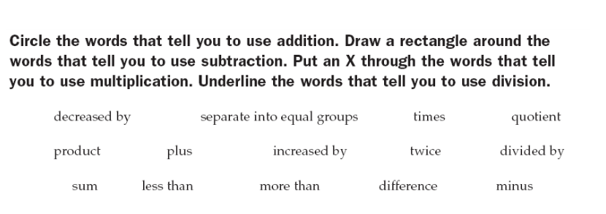

Addition: sum, plus, more than, increased by

Subtraction: decreased by, less than, difference, minus

Multiplication: product, times, twice

Division: separate into equal groups, quotient, divided by

**Key Vocabulary:**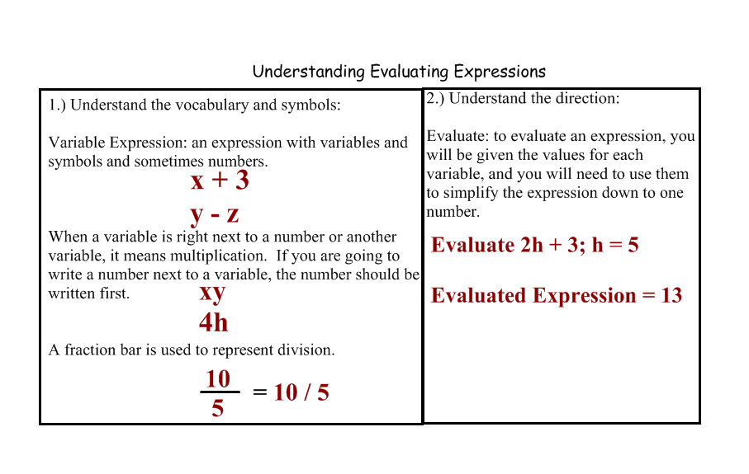

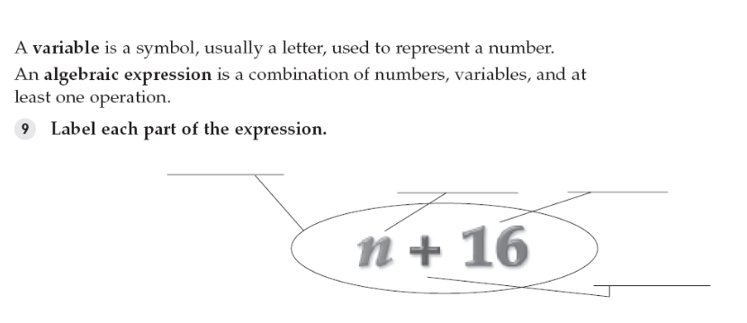

algebraic/variables expression

variables

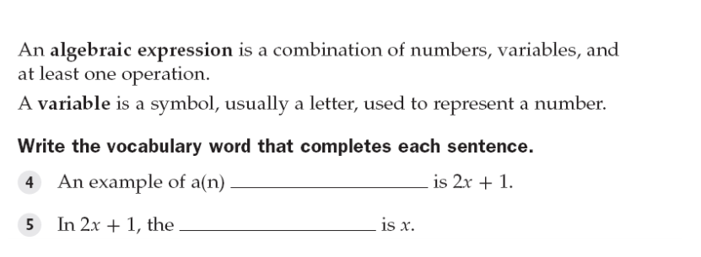

**Guided Notes:**

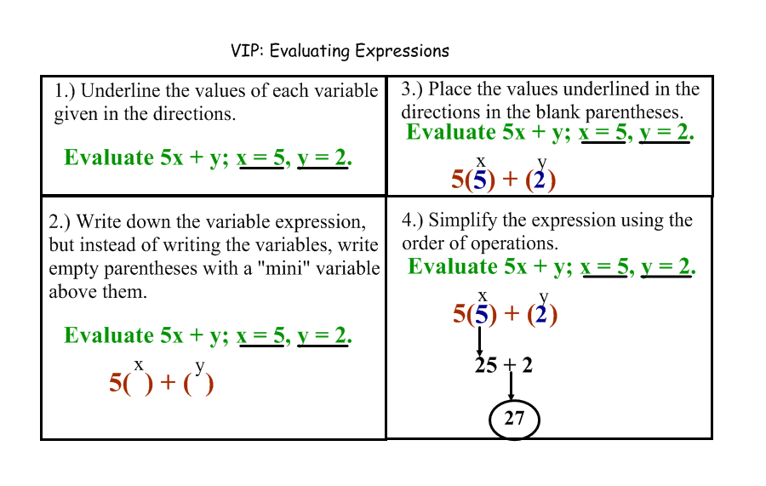

**Eric’s Soup Shop**

|  |  |
| --- | --- |
| **Soup** | **Price** |
| Generation Soup | $9 |
| Angel’s Souper Soup | $7 |
| Eh Soup | $5 |
| Aldo’s All Right Soup | $6 |
| Cold Soup | $3 |
| Raul’s Soup | $1 |
| Diana’s Clam Chowder | $5 |
| Not Chicken Soup | $3 |
| Perfect Super Soup | $2 |
| Brownie Soup | $5 |
| Revolutionary Soup | $7 |
| Tapatio Soup | $54 |
| Noodle Soup | $3 |
| Unicorn Soup | $3 |

**g + u = ? = 12**

**b + 2e = ? = 15**

**(½)c + p*u = ? = 7.5**

**(t-u)/b+10 = ? = 101/5**

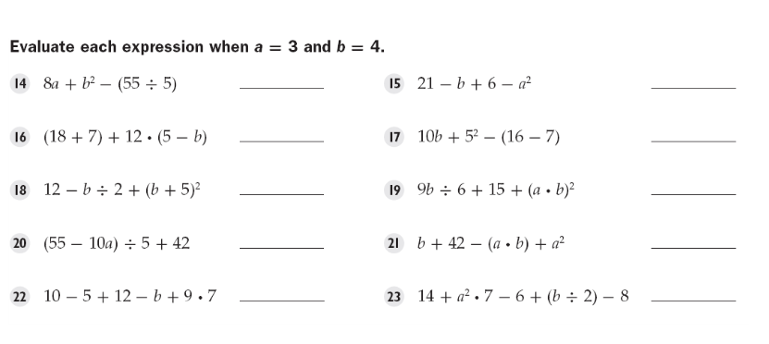

29 14

37 56

85 165

47 43

74 23

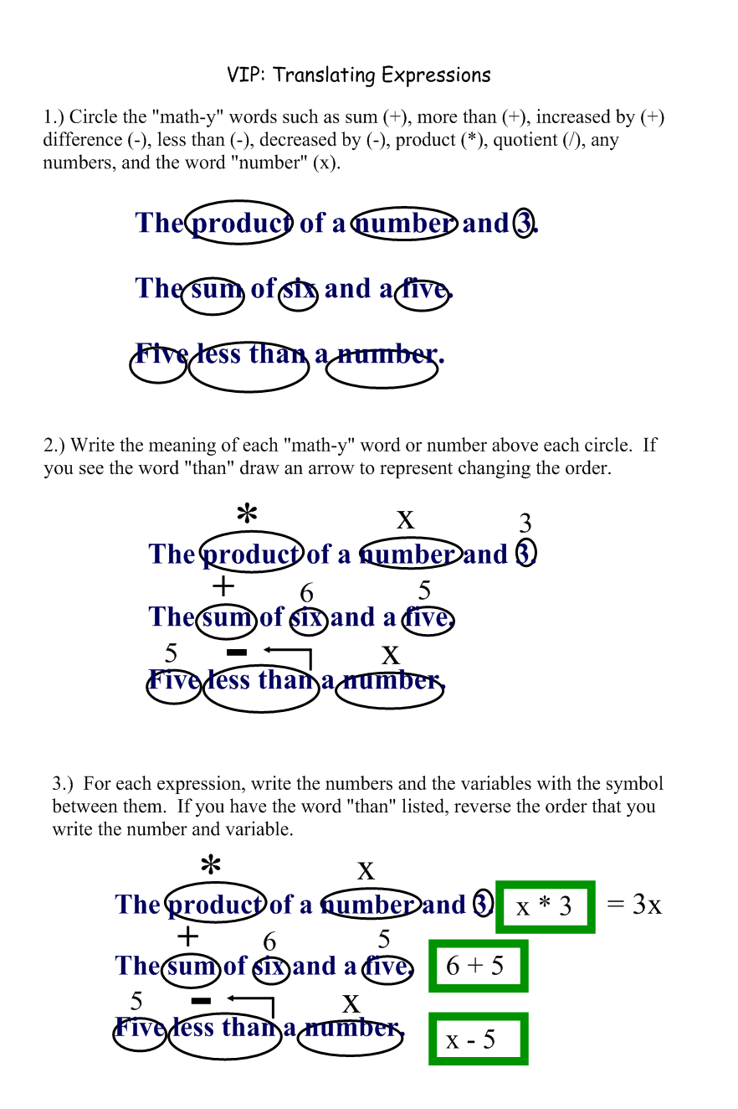

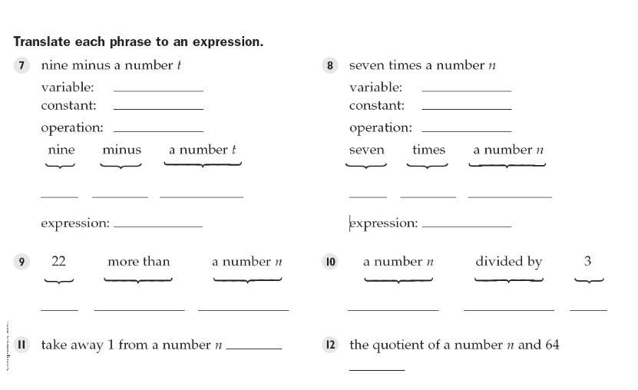

t n

9 7

subtraction multiplication

9 - t 7 x n

9 – t 7n

22 + n n / 3

n-1 n/64

s + 15

6h

d + 3

5d

2000s

16c

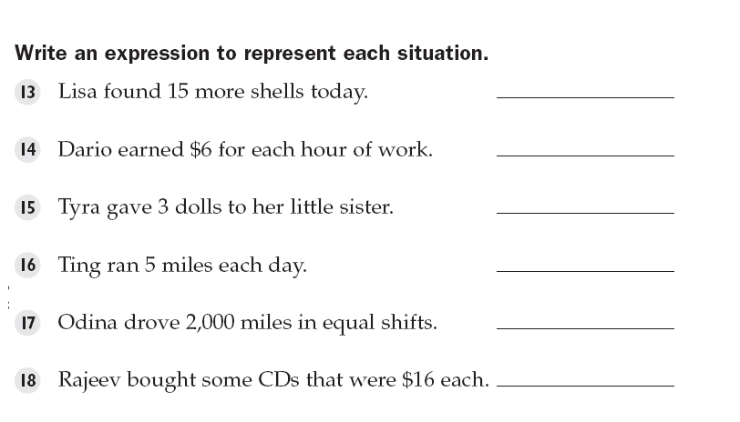

**Structured/Guided Practice:**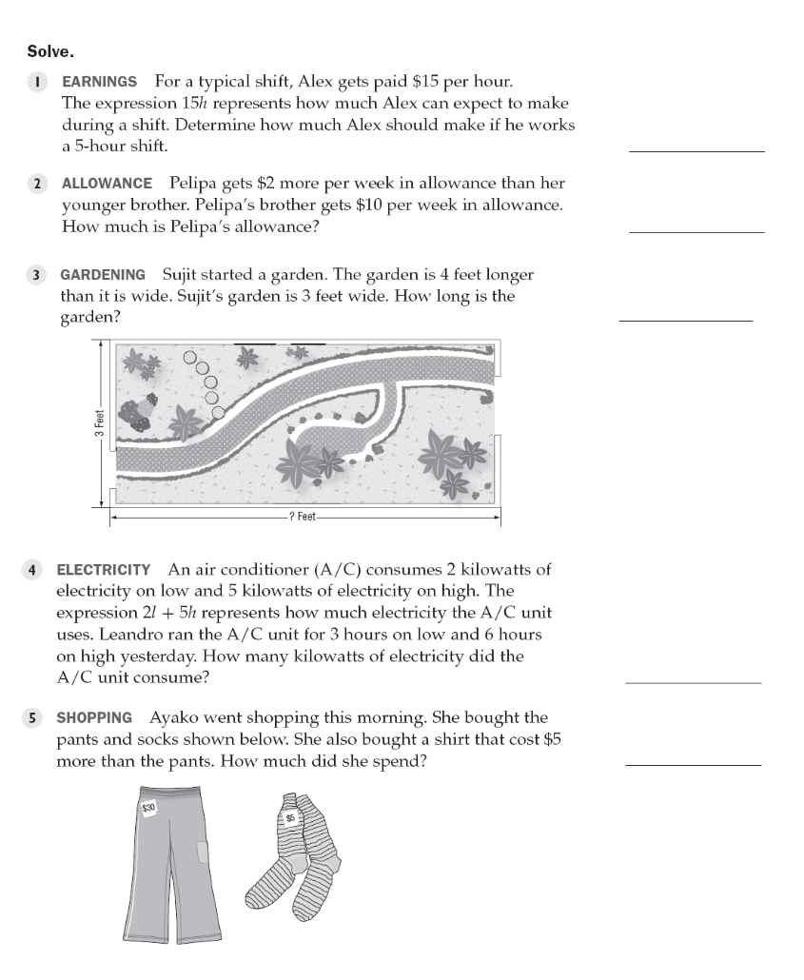

$75

$12

7 feet

36 kilowatts

$70

**Independent Practice:**

1. **Evaluate the expression when x = 8, y = 9, and z = 0**
$x^{2}-\frac{z}{y}×\left(x+y\right)$

$5x+2y-\left(z+15\right)*y$

2. **I have twice as many photographs as my brother does. Write an expression that represents the number of photos I have.**
3. **Laura has two more than twice the number of markers I have. Write an expression for the number of markers that Laura has.**
4. **The average cartoon character has one less finger than I do. Write an expression for the number of fingers the cartoon character has (assume you don’t know how many fingers I have).**
5. **I have half the number of cards my brother has. The number of cards my brother has is five times the number of pencils my dad has. The number of pencils my dad has is five more than the number of erasers my mom has. Write an expression for the number of cards I have, in terms of the number of erasers my mom has.**

1.a. 64

b. 77

2. 2p

3. 2m + 2

4. f - 1

5. (5/2)(e + 5)